Instruction

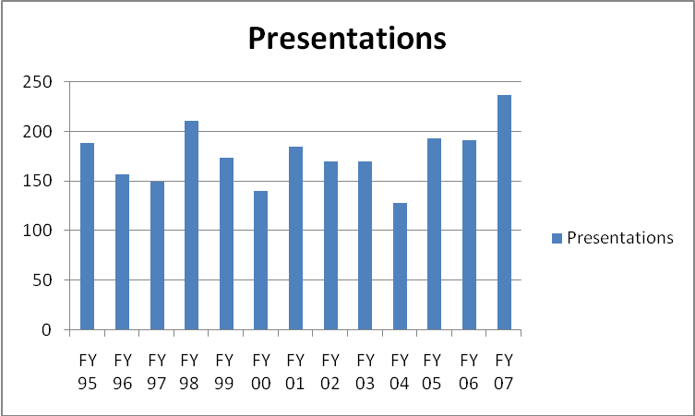

The number of Library Instruction sessions has been relatively stable for a number of years. In 2004 a renovation project required librarians to become mobile and take instruction to classrooms and computer labs across campus, thus reducing the number of sessions. In FY 2005 the number of instruction sessions increased by 33%. In 2006 the number of instruction session remained stable; the number of presentations increased by 20% in 2007. Librarians provide instruction at The University Center and at other off campus sites.

