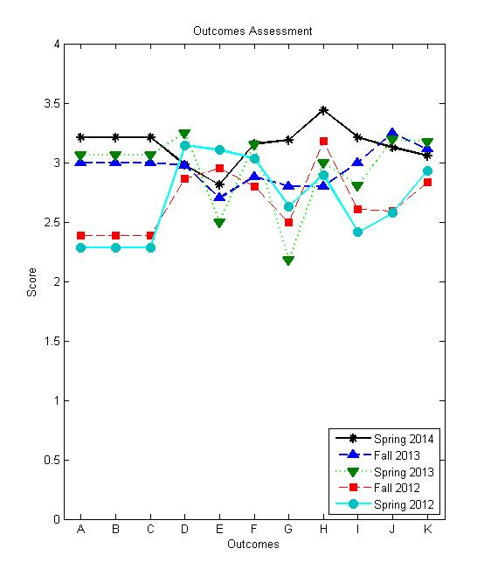

|  |  |  |  |  |  |  |
| --- | --- | --- | --- | --- | --- | --- |
| Criterion Term | | Spring 2012 | Fall 2012 | Spring 2013 | Fall 2013 | Spring 2014 |
| Software Engineering  Presentation | Groups | G1(4), G2(4), G3(4), and G4(2) | G1(5), G2(5), and G3(4) | G1(7), G2(7), and G3(10) | G1(7) and G2(7) | G1(8), G2(8), and G3(5) |
| Students | 14 | 13 | 24 | 14 | 21 |
| Professors | 3 | 3 | 3 | 2 | 3 |
| Ethics Evaluation | Students | 19 | 22 | 11 | 15 |  |
| Outcomes  (avg ± std) | A | 2.2857 ± 1.1053 | 2.3846 ± 0.9351 | 3.0641 ± 0.6995 | 3.0000 ± 0.7201 | 3.2127 ± 0.4168 |
| B | 2.2857 ± 1.1053 | 2.3846 ± 0.9351 | 3.0641 ± 0.6995 | 3.0000 ± 0.7201 | 3.2127 ± 0.4168 |
| C | 2.2857 ± 1.1053 | 2.3846 ± 0.9351 | 3.0641 ± 0.6995 | 3.0000 ± 0.7201 | 3.2127 ± 0.4168 |
| D | 3.1464 ± 0.8236 | 2.8651 ± 0.8909 | 3.2475 ± 0.8292 | 2.9747 ± 0.8926 | 2.9802 ± 0.8707 |
| E | 3.1053 ± 1.0078 | 2.9545 ± 0.9872 | 2.5000 ± 1.1019 | 2.7000 ± 0.9154 | 2.8125 ± 0.9311 |
| F | 3.0356 ± 0.7720 | 2.7965 ± 0.8379 | 3.1527 ± 0.8189 | 2.8810 ± 0.8431 | 3.1573 ± 0.7827 |
| G | 2.6316 ± 0.8307 | 2.5000 ± 0.9129 | 2.1818 ± 1.0787 | 2.8000 ± 0.9411 | 3.1875 ± 1.0468 |
| H | 2.8947 ± 0.8753 | 3.1818 ± 0.8528 | 3.0000 ± 0.6325 | 2.8000 ± 1.0142 | 3.4375 ± 0.6292 |
| I | 2.4143 ± 1.0559 | 2.6068 ± 1.0039 | 2.8077 ± 0.8205 | 3.0000 ± 0.7114 | 3.2111 ± 0.3751 |
| J | 2.5762 ± 0.8627 | 2.5897 ± 0.6774 | 3.1923 ± 0.5711 | 3.2500 ± 0.4410 | 3.1270 ± 0.3356 |
| K | 2.9293 ± 0.9043 | 2.8323 ± 0.8736 | 3.1752 ± 0.7495 | 3.1131 ± 0.8147 | 3.0552 ± 0.6409 |
| Objectives  (avg ± std) | E1 | 2.3823 ± 1.0500 | 2.5092 ± 0.9339 | 2.9725 ± 0.7506 | 3.0357 ± 0.6822 | 3.1998 ± 0.3877 |
| E2 | 2.5782 ± 1.0332 | 2.6276 ± 0.9245 | 3.0616 ± 0.7565 | 3.0714 ± 0.7462 | 3.1393 ± 0.5137 |
| E3 | 2.9843 ± 0.9004 | 2.8041 ± 0.9060 | 3.1709 ± 0.8437 | 2.9440 ± 0.8697 | 3.0483 ± 0.8178 |
| E4 | 2.4772 ± 1.0440 | 2.6978 ± 1.0011 | 2.8163 ± 0.8129 | 2.9697 ± 0.7620 | 3.2288 ± 0.4031 |