**Dr. Sophia McClennen's**

**GENERAL EVALUATION RUBRIC FOR PAPERS**

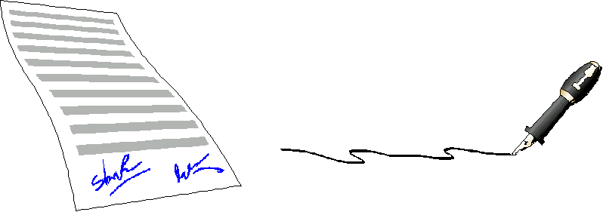

These are general guidelines used in assessing written work. Any grade deduction for misspelled words is in addition to these guidelines.

**The Superior Paper (A/A-)**

**Thesis:** Easily identifiable, plausible, novel, sophisticated, insightful, crystal clear. Connects well with paper title.

**Structure:** Evident, understandable, appropriate for thesis. Excellent transitions from point to point. Paragraphs support solid topic sentences.

**Use of evidence:** Primary source information used to buttress every point with at least one example. Examples support mini-thesis and fit within paragraph. Excellent integration of quoted material into sentences. Demonstrates an in depth understanding of the ideas in the assigned reading and critically evaluates/responds to those ideas in an analytical, persuasive manner.

**Analysis:** Author clearly relates evidence to "mini-thesis" (topic sentence); analysis is fresh and exciting, posing new ways to think of the material. Work displays critical thinking and avoids simplistic description or summary of information.

**Logic and argumentation:** All ideas in the paper flow logically; the argument is identifiable, reasonable, and sound. Author anticipates and successfully defuses counter-arguments; makes novel connections to outside material (from other parts of the class, or other classes), which illuminate thesis. Creates appropriate college level, academic tone.

**Mechanics:** Sentence structure, grammar, and diction excellent; correct use of punctuation and citation style; minimal to no spelling errors; absolutely no run-on sentences or comma splices. Conforms in every way to format requirements.

**The Good Paper (B+/B)**

**Thesis:** Promising, but may be slightly unclear, or lacking in insight or originality. Paper title does not connect as well with thesis or is not as interesting.

**Structure:** Generally clear and appropriate, though may wander occasionally. May have a few unclear transitions, or a few paragraphs without strong topic sentences.

**Use of evidence:** Examples used to support most points. Some evidence does not support point, or may appear where inappropriate. Quotes well integrated into sentences. Demonstrates a solid understanding of the ideas in the assigned reading and critically evaluates/responds to those ideas in an analytical, persuasive manner.

**Analysis:** Evidence often related to mini-thesis, though links perhaps not very clear. Some description, but more critical thinking.

**Logic and argumentation:** Argument of paper is clear, usually flows logically and makes sense. Some evidence that counter-arguments acknowledged, though perhaps not addressed. Occasional insightful connections to outside material made. Mostly creates appropriate college level, academic tone.

**Mechanics:** Sentence structure, grammar, and diction strong despite occasional lapses; punctuation and citation style often used correctly. Some (minor) spelling errors; may have one run-on sentence or comma splice. Conforms in every way to format requirements.

**The Borderline Paper (B-/C+)**

**Thesis:** May be unclear (contain many vague terms), appear unoriginal, or offer relatively little that is new; provides little around which to structure the paper. Paper title and thesis do not connect well or title is unimaginative.

**Structure:** Generally unclear, often wanders or jumps around. Few or weak transitions, many paragraphs without topic sentences.

**Use of evidence:** Examples used to support some points. Points often lack supporting evidence, or evidence used where inappropriate (often because there may be no clear point). Quotes may be poorly integrated into sentences. Demonstrates a general understanding of the ideas in the assigned reading and only occasionally critically evaluates/responds to those ideas in an analytical, persuasive manner.

**Analysis:** Quotes appear often without analysis relating them to mini-thesis (or there is a weak mini-thesis to support), or analysis offers nothing beyond the quote. Even balance between critical thinking and description.

**Logic and argumentation:** Logic may often fail, or argument may often be unclear. May not address counter-arguments or make any outside connections. Occasionally creates appropriate college level, academic tone, but has some informal language or inappropriate slang.

**Mechanics:** Problems in sentence structure, grammar, and diction (usually not major). Some errors in punctuation, citation style, and spelling. May have some run-on sentences or comma splices. Conforms in almost every way to format requirements.

**The "Needs Help" Paper (C/C-)**

**Thesis:** Difficult to identify at all, may be bland restatement of obvious point.

**Structure:** Unclear, often because thesis is weak or non-existent. Transitions confusing and unclear. Few topic sentences.

**Use of evidence:** Very few or very weak examples. General failure to support statements, or evidence seems to support no statement. Quotes not integrated into sentences; "plopped in" in improper manner. Demonstrates a little understanding of (or occasionally misreads) the ideas in the assigned reading and does not critically evaluates/responds to those ideas in an analytical, persuasive manner.

**Analysis:** Very little or very weak attempt to relate evidence to argument; may be no identifiable argument, or no evidence to relate it to. More description than critical thinking.

**Logic and argumentation:** Ideas do not flow at all, usually because there is no argument to support. Simplistic view of topic; no effort to grasp possible alternative views. Does not create appropriate college level, academic tone, and has informal language or inappropriate slang.

**Mechanics:** Big problems in sentence structure, grammar, and diction. Frequent major errors in citation style, punctuation, and spelling. May have many run-on sentences and comma splices. Does not conform to format requirements.

**The "Really Needs Help" Paper (D+/D)**

Is like **The "Needs Help" Paper** but the problems are more serious or more frequent.

**The Failing Paper**

Shows obviously minimal lack of effort or comprehension of the assignment. Very difficult to understand owing to major problems with mechanics, structure, and analysis. Has no identifiable thesis, or utterly incompetent thesis. Does not follow paper guidelines for length and format. Plagiarizes.

*These guidelines have been adapted from excellent grading rubrics available at:* <http://www.fordham.edu/halsall/med/rubric.html> and <http://www.sheftman.com/ewrt1a/dillard/dilscale.html>

|  |  |
| --- | --- |
| **Created and Maintained by Sophia A. McClennen**  **Copyright** [**Sophia A. McClennen**](http://www.personal.psu.edu/users/s/a/sam50/default.htm) **2002**  **For EDUCATIONAL PURPOSES ONLY** |  |